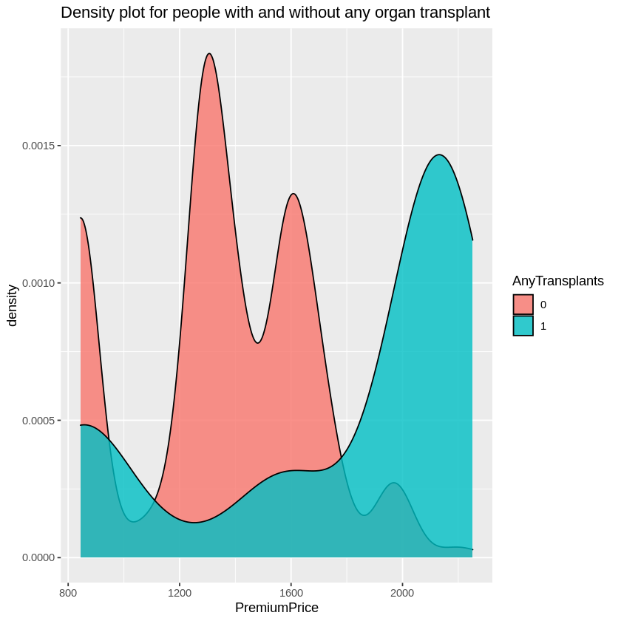

Density plots for people with and without any organ transplant problems:

The highest density price of organs with transplants is between 2000-2200, and the highest density of organs without transplants is between 1200-1400. The difference between the premiums is 800, but the density of organs without transplants is higher than that of organs with transplants.

Density plot of chronic diseases:

People with chronic conditions have higher density premiums than people without chronic conditions,

The highest 1600-1800 premium for the highest density of patients with chronic diseases

The highest premium for the density of patients without chronic diseases is: 1200-1400

The densities with and without chronic disease were about the same, both exceeding 0.0015 and none to 0.002

When the premium exceeds 1400, the density of those with chronic diseases is higher than that of those without chronic diseases

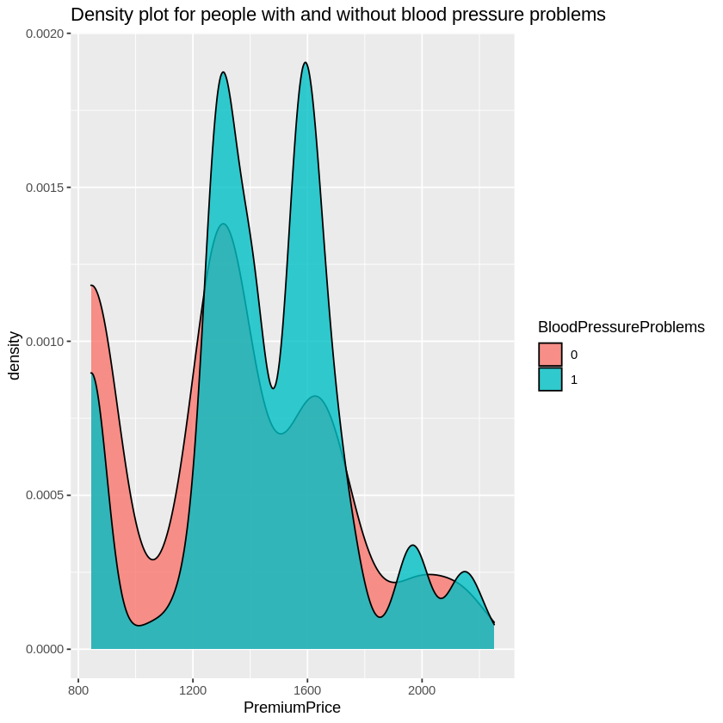

Density plot for people with and without blood pressure problems :

Between 1300-1600, people with blood pressure have higher density than those without blood pressure, proving that people with blood pressure are more inclined to premium at 1600

For people without blood pressure problems, the highest density premium is around 1300, indicating that regardless of whether there is a blood pressure problem, the highest density price is around 1300.

Density plot for diabetic and non-diabetic problems:

The heatmaps of people with and without diabetes problems are very similar to those with and without blood pressure problems. They are both at 1300-1600. The density of problems is the highest, and the density of no problems is the highest at 1300. However, after the diabetes problem exceeds 1700, there is no problem. The density is higher, indicating that no problem is more acceptable to a high premium than a problem,

Density plots for people with and without a history of cancer:

Density premium with no family history of cancer peaks at 1300,

People with a family history of cancer had a stable density without mutations at a certain price.

The highest density with a family history of cancer is at 1700.

The price difference between those with and without a family history of cancer is 400, but the difference in density is about 0.01, which is the largest price difference in all comparison graphs with density and the highest density.

Density plot for people with and without allergies:

The price is 1300 when the density is the highest among people without allergies, and the price is also 1300 when the density is the highest among people with allergies, but the density of people without allergies is higher than that of people with allergies, which means that at the price of 1300, people without allergies have a higher density. easier to accept

The density map of the population with different number of operations:

In the 0th and 1st operations, the density trend is relatively stable, while the density in the second operation is very high, as high as 0.015 or more, and the price at this time is 1600. The 0th and 1st operations have the highest density. The premium is 1200 -1400, but the density at 0 operations is slightly higher than that at 1 operation.

Any transplant, blood pressure, diabetes, chronic disease, family history of cancer, major surgery, known allergies

These types of analytical evaluations show that:

Among them, the premium of any transplant, blood, diabetes is higher and the density is higher, and the premium is around 1600, and the density is more than 0.0115

However, the price of family medical history and allergies without the disease is higher, the premium is around 1200-1400, and the density is also higher, and the density is also more than 0.015